Ahmed Mahmoud Hassan Mohamed
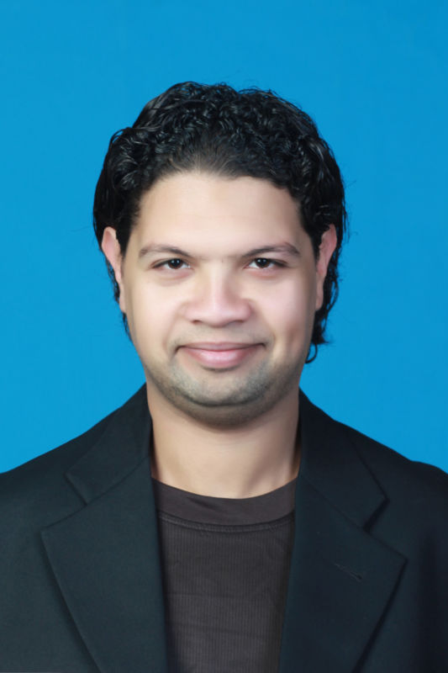
Assistant Lecturer of Biochemistry
Permanent address: Department of Agriculture
Biochemistry, University of Benha, Egypt.
E-mail: ahmed.mohamed@fagr.bu.edu.eg
Phone: (Cell): (+2) 01152939174

Personal details

Date and Place of Birth : 1st August 1986, Elbehara, Egypt
Nationality : Egyptian
Marital status : Married

Academic degrees

PhD. (Nano Bioanalysis and Food Safety): Department of Food Science, Huazhong Agricultural University (HZAU), China, Graduated date: June 2019.
Thesis title: “Sensors to detect Sulfur Pesticide residues & Biothiols”
M.Sc. (Biochemistry): Department of Agriculture Biochemistry, BenhaUniversity (BU), Egypt, Graduated date: February 2012.
Thesis title: “Biochemical studies on canola seeds”
B.Sc. (Biochemistry), Department of Agriculture Biochemistry, BenhaUniversity (BU), Egypt, Graduated date: July 2007.

Research Interests

Biosensors

Nanotechnology

Chemical Optics and Spectroscopy

Proteins

Environmental Chemistry

Current Scientific Activities

- Published book under title of “Biochemical studies on canola seeds” with NOOR publishing (ISBN: 978-3-330-80257-5) 2017.
- Published paper under title of “Single microbead-based fluorescence “turn on” detection of biothiols by flow cytometry”. Ahmed Mohamed, Xuemeng Li, Jinquan Li, Chuangye Lin, Abdullah M. Asiri, Hadi M. Marwani, Suhua Wang, Zhidong Xiao*, Bin Li*, Chao Yuan*. Talanta, 2019, 195: 197–203.
- Reviewer at Analytica Chimica Acta (ACA) at Elsevier.
- http://www.bu.edu.eg/staff/ahmedmohamed6
- https://scholar.google.com.eg/citations?user=HWtoTSkAAAAJ&hl=en
- https://www.researchgate.net/profile/Ahmed_Mohamed75
- https://www.facebook.com/ahmed.m.hassan.5439
- https://twitter.com/crazymedo3000
- https://www.linkedin.com/in/ahmed-mohamed-13b9a9b5/

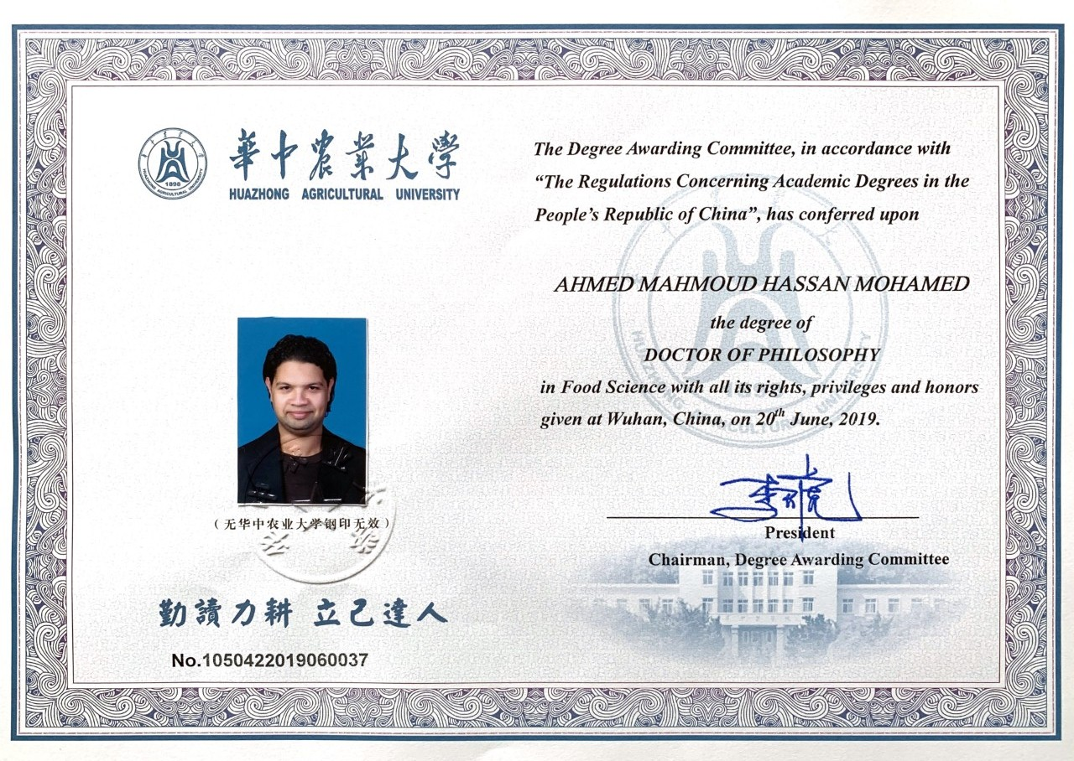
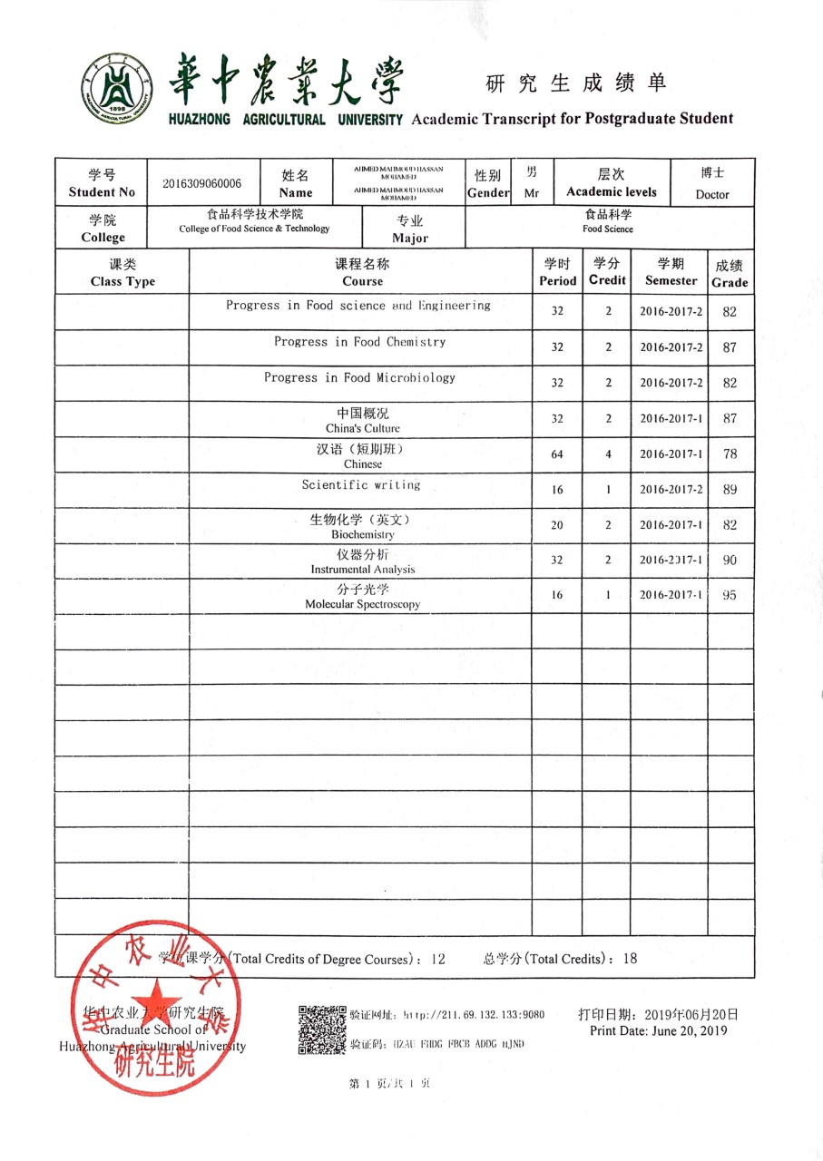
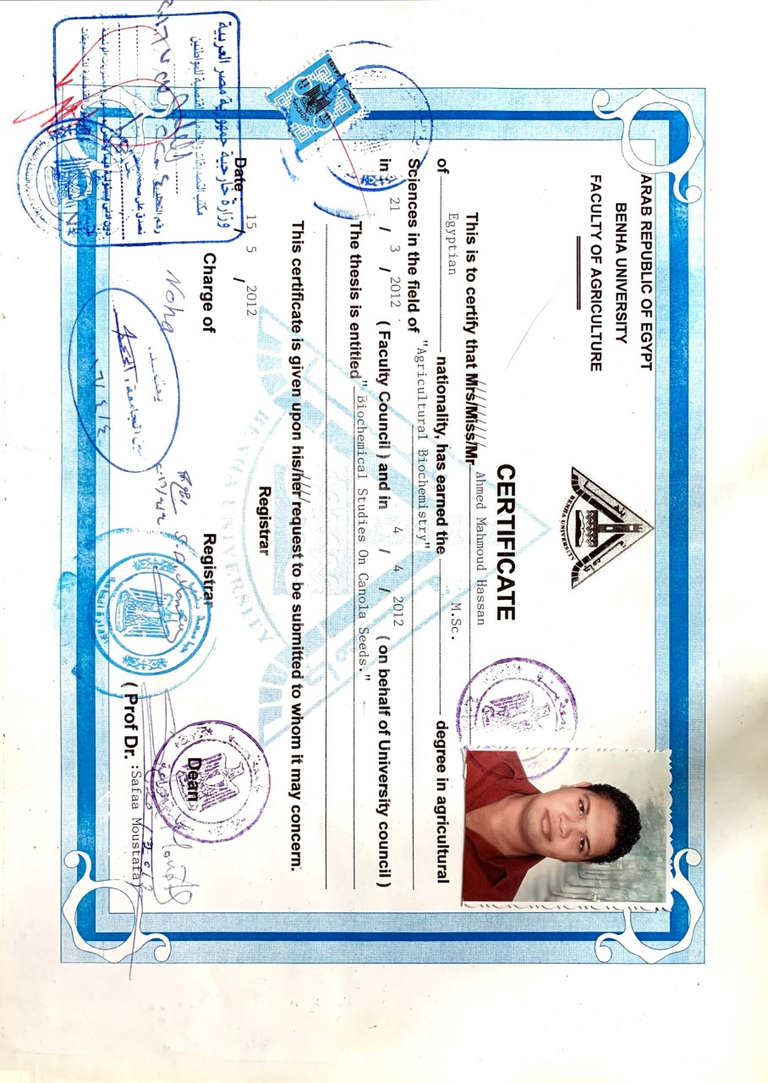
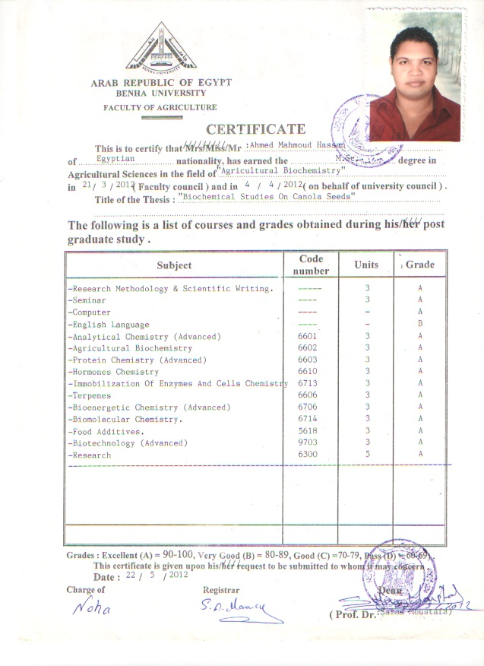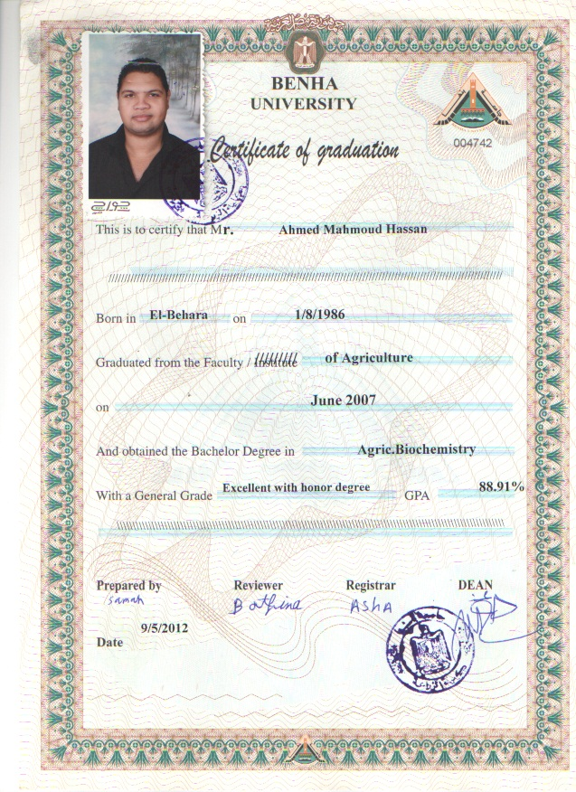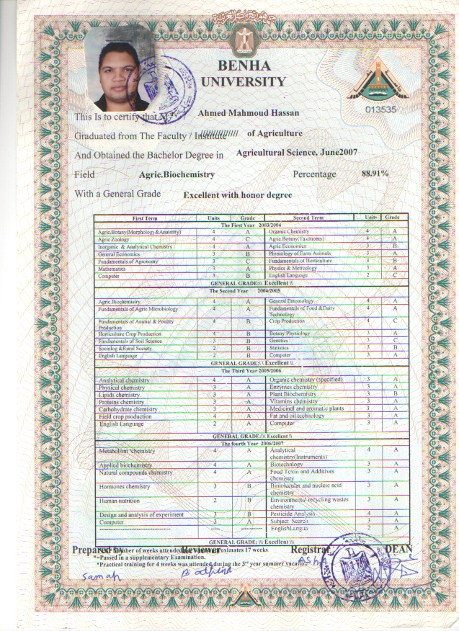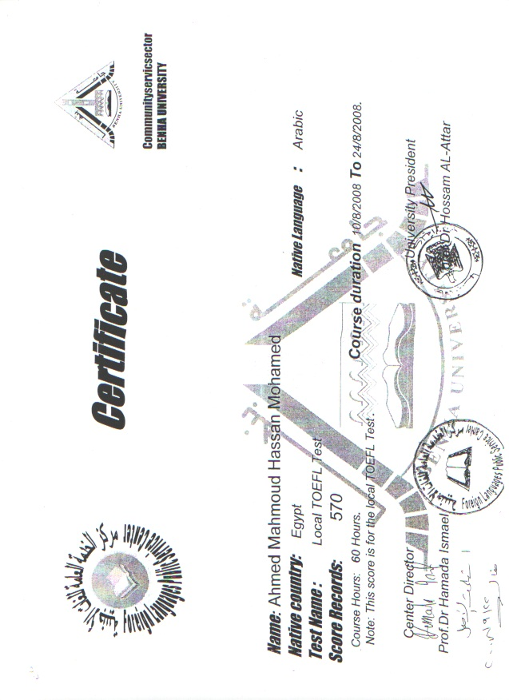
Teaching experience

- Teaching some of practical courses (Inorganic and Analytical chemistry – Organic chemistry) to students in the first year in my faculty.
- Teaching some of practical course (Agric. Biochemistry) to students in the second year in my faculty.
- Teaching some of practical courses (Analytical chemistry – Physical chemistry – Proteins chemistry – Plant biochemistry) to students in the third year in my faculty.
- Teaching some of practical courses (Metabolism chemistry – Applied biochemistry – Natural compounds chemistry – Biotechnology – Bimolecular and nucleic acid chemistry – Environmental recycling wastes chemistry) to students in the fourth year in my faculty.
Updated: June 2019

